

No. CANEC2105982401 Date: 20 Apr 2021 Page 1 of 4

PROVINCE CHINA

The following sample(s) was/were submitted and identified on behalf of the clients as : Aluminum jar SGS Job No. : CP21-016625 - GZ
Date of Sample Received : 14 Apr 2021
Testing Period : 14 Apr 2021 - 19 Apr 2021
Test Requested : Selected test(s) as requested by client.

Test Method : Test Results :
Please refer to next page(s). Please refer to next page(s).

Signed for and on behalf of
SGS-CSTC Standards Technical Services Co., Ltd. Guangzhou Branch



Sasa Zhi
Approved Signatory

Test Results :

Test Part Description :

Specimen No.. SGS Sample ID. Description. SN1 CAN21-059824.001 Silvery metal

Remarks :

(1) 1 mg/kg = 0.0001%
- MDL = Method Detection Limit
- ND = Not Detected ( < MDL )
- "-" = Not Regulated

Elemental analysis, Hexavalent Chromium(Cr(VI)) .

Test Method : With reference to IEC 62321-4:2013+A1:2017, IEC 62321-5:2013, IEC 62321-7-1:2015,
analyzed by ICP-OES and UV-Vis .

Test Item(s) | Limit | Unit | MDL | 001
Cadmium (Cd) | 100 | mg/kg | 2 | ND
Lead (Pb) | 1,000 | mg/kg | 2 | 5
Mercury (Hg) | 1,000 | mg/kg | 2 | ND
Hexavalent Chromium (Cr(VI))▼ | - | µg/cm² | 0.10 | ND
Notes :
  - The limit(s) was/were submitted by applicant.
  - ▼= a. The sample is positive for CrVI if the CrVI concentration is greater than 0.13 μg/cm². The sample coating is considered to contain CrVI
b. The sample is negative for CrVI if CrVI is ND (concentration less than 0.10 μg/cm²). The coating is considered a non-CrVI based coating
c. The result between 0.10 μg/cm² and 0.13 μg/cm² is considered to be inconclusive - unavoidable coating variations may influence the determination
Information on storage conditions and production date of the tested sample is unavailable and thus Cr(VI) results represent status of the sample at the time of testing.

ATTACHMENTS

Pb/Cd/Hg/Cr6+ Testing Flow Chart

1) These samples were dissolved totally by pre -conditioning method according to below flow chart. (Cr6+ test method excluded ).
- Alkali Fusion / Dry Ashing
- Acid to dissolve
Solution
ICP-OES/AAS
Residue
Separating to get aqueous phase
Digesting at 60°C by ultrasonication
pH adjustment
DATA
DATA
UV-Vis.
Adding 1,5- diphenylcarba zide for color development

Sample Preparation

Cr6+
Pb/Cd/Hg
Sample Measurement
Acid digestion with microwave / hotplate
Digesting at 150~160℃
Dissolving by ultrasonication
Filtration
Boiling water extraction
Nonmetallic material
C/PVC | Others

Metallic material
ABS/P

DATA
Adding 1,5- diphenylcarbazide for color development
UV-Vis

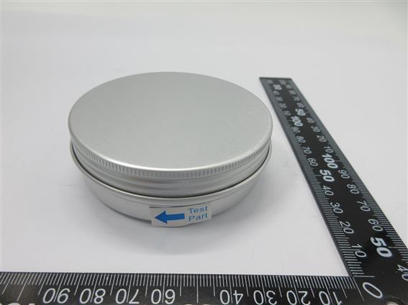
Sample photo:

CANEC2105982401

CAN21-059824.001

SGS authenticate the photo on original report only
*** End of Report ***

